Both United Way of Lake County (UWLC) and the partner agency, ___________________, agree to:
Honor this agreement for a one year period, the term of funding, unless either party requests in writing, the termination or modification of this agreement.

United Way of Lake County reserves the right at any time during this agreement to reduce or withhold funding, require the agency to reimburse funding, place the agency on probationary status or terminate the agreement if any of the following conditions occur:

- Failure on the part of the agency to adhere to the standards or policies set forth and covered in this agreement.
- Failure on the part of the program to deliver the agreed upon services.
- Significant changes in conditions that result in the inability of the agency to effectively operate the program.

During the course of this agreement, it is the responsibility of both United Way of Lake County and the agency to communicate any topics of concern and to consult in a timely matter when significant changes, issues, or misunderstandings arise.

In the event of unforeseen circumstances related to the availability of funds, UWLC reserves the right to adjust allocations.

United Way of Lake County agrees to:
- Represent the communities we serve in an exemplary fashion, with a diverse and representative Board of Directors.
- Practice nondiscrimination in the employment and promotion of staff, recruitment and utilization of program volunteers and in the delivery of services to clients.
- Respect the agency’s autonomy and right to determine its own policies, procedures and programs in meeting its mission and vision statements.
- Implement the UWLC Strategic Plan, incorporating community input and involvement in the process.
- Continually assess and seek solutions to community needs, including serving as a community facilitator when appropriate. Conduct public relations program to promote the understanding of community issues, support of partner agencies and understanding of UWLC’s role in addressing community needs.
- Conduct an annual county-wide fundraising campaign to meet the needs of the county as determined by the UWLC Board of Directors.
- Be a responsible steward of funds contributed to UWLC by:
- Allocating financial resources based upon community needs and assets available and a community/volunteer based review process.
- Following the accepted accounting principles and have an annual independent audit.
- Monitoring the performance of funded programs against the outcomes stated in the original funding proposal.
- Provide agencies support through volunteer referrals, in-kind donations as available, group project opportunities, technical assistance, opportunities to network and other appropriate information. UWLC staff will avoid any involvement with a current or potential UWLC grantee which conflicts or appears to conflict with the best interest of UWLC and is not deemed to be appropriate by the UWLC Board of Directors.
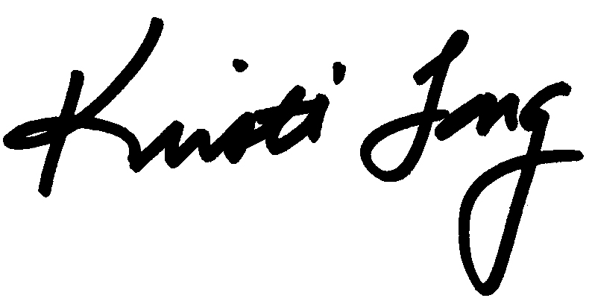

Reviewed and approved by: _______________________________
Kristi Long, President & CEO, United Way of Lake County
May 16, 2017

The partner agency, ________________________________________________, agrees to:
- Accept the allocation of funds to operate programs and deliver services to support the purposes of the grant during the funding period. Any grant funds not expended for the purposes of the grant within the funding period will be returned to United Way of Lake County.
- Immediately notify United Way of Lake County regarding any legal, financial, organizational issues, primary staff changes, or program changes within the funding period which may impact the agency’s ability to operate and /or deliver stated services.
- Ensure that the United Way of Lake County grant represents no more than 50% of the program’s revenue for the entirety of the funding period.
- Submit all required documentation within United Way of Lake County’s guidelines and required timelines. Required documentation includes but is not limited to: Memorandum of Agreement, ACH, Anti-Terrorism Compliance Measures, Year End Report Information Sheet, and Year End Reports.
- Promote the partnership with United Way of Lake County and the funding to your agency by:
  - Including the United Way of Lake County logo and a link to www.LIVEUNITEDLakeCounty.org on your website.
  - Recognizing United Way of Lake County funding in your annual report.
- Support the Find Help Lake County Initiative by:
  - Actively maintaining current information on all agency and program records on the Find Help Lake County website by completing all required annual updates and regularly submitting updates to record information as needed.
  - Including the Find Help Logo and a link to www.FindHelpLakeCounty.org on your agency’s website.
- Submit financial documentation, based on their annual gross revenue, at the time of submission of the Year End Report or within four months following the completion of the agency’s fiscal year:
- Annual gross revenue up to $299,999 - A review of financial statements from an external accountant is required of all agencies with gross revenues up to $299,999. The audit must specify funded program expenses and be performed by an independent certified public accountant in accordance with the Standards of Accounting and Financial Reporting for Voluntary Health and Welfare Organizations. Agencies must submit a review from FY 2016 or later.
- Annual gross revenue of $300,000 or more - An annual Independent audit with full reporting of all agency and program expenses is required if annual gross revenue exceeds $300,000. Agencies must submit an audit from FY 2016 or later.

Mandatory Agency Requirements:
- Agency provides services in Lake County, Illinois.
- Agency has a volunteer Board of Directors representative of the service delivery area. The Board meets at least quarterly and contains at least eight active members who are not related to the Executive Director or agency staff. The duties and responsibilities of the Board are defined in writing.
- Agency has an effective fiscal management system including complete and accurate financial records of all income and expenses by funded programs. United Way of Lake County has the right to review and request this information as needed, with appropriate notice to the agency.
- Agency’s administrative management includes written personnel policies, guidelines and job descriptions for program staff and volunteers.
- Agency practices nondiscrimination in the employment and promotion of staff, recruitment and utilization of program volunteers and in the delivery of services to clients. Agency has a written and enforced affirmative action plan, grievance procedure, non-discrimination policy and sexual harassment policy.
- Agency is determined by the Internal Revenue Service to be an organization described in section 501(c) 3 of the Internal Revenue Code of 1986. If the determination is revoked or modified, please notify UWLC immediately. UWLC will not be required to make any payment hereunder if agency loses its federal tax-exempt status.

The contents of the FY 2018 Memorandum of Agreement have been reviewed and approved by:

Executive Director of _______________________________________

Print Name: _______________________________________________

Signature: ________________________________________________
(Electronic signatures will not be accepted)

Date: _____________________________________________________

